Task 4

Search Course

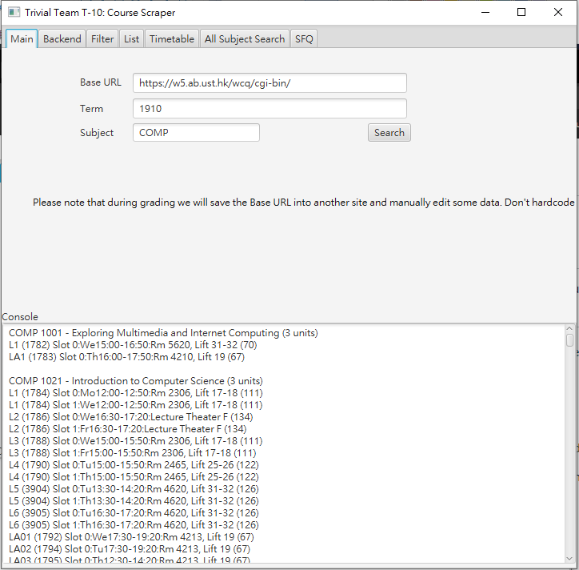

Enroll some Course (non-overlapping)

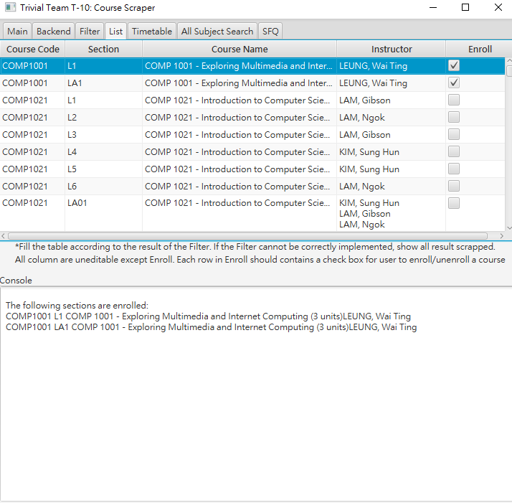

Timetable is displayed.

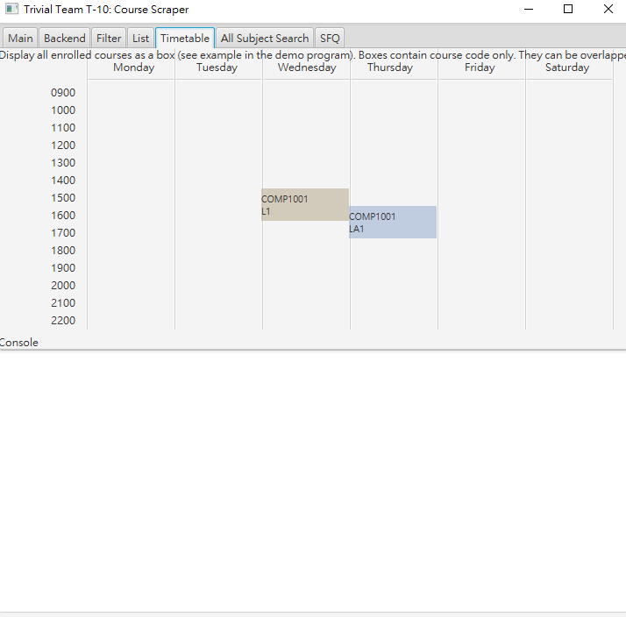

Enroll some course (overlapping)

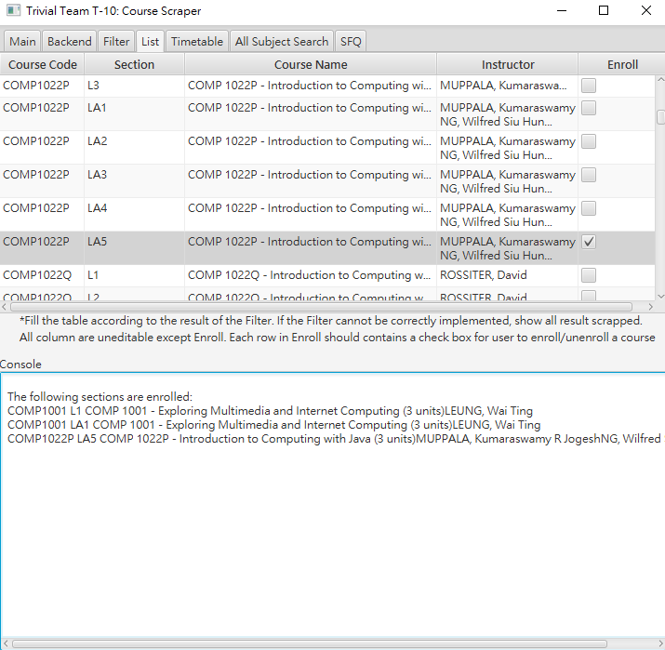

Overlapping Timetables

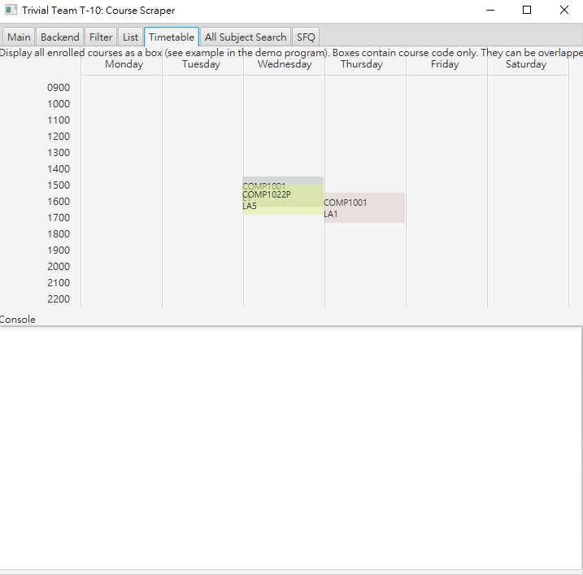

Task 6

The Find SFQ with my enrolled courses button is disabled before search

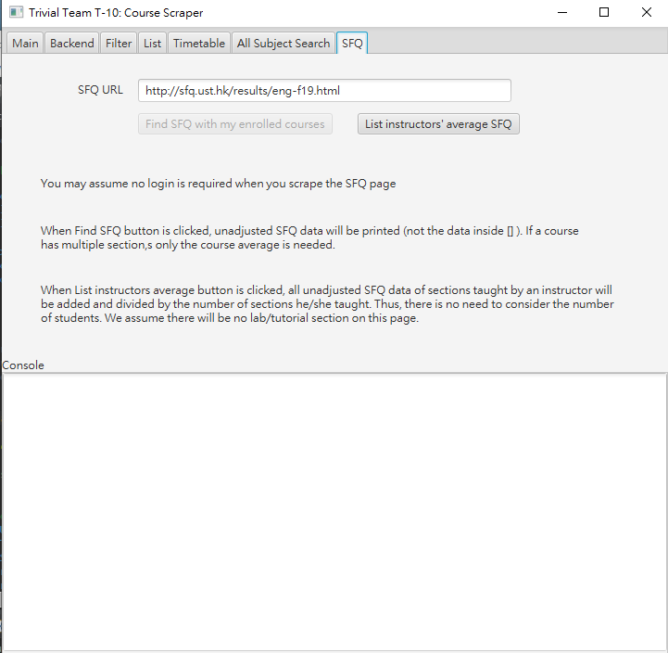

That button is enabled after search or All subject search is clicked.

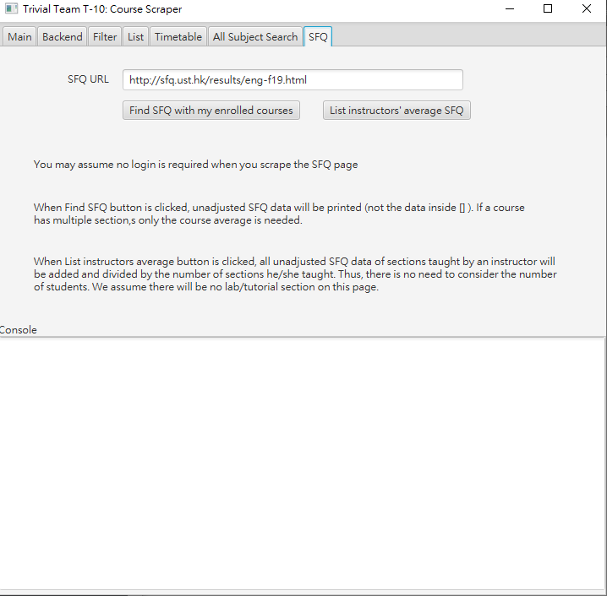

Some courses are enrolled,

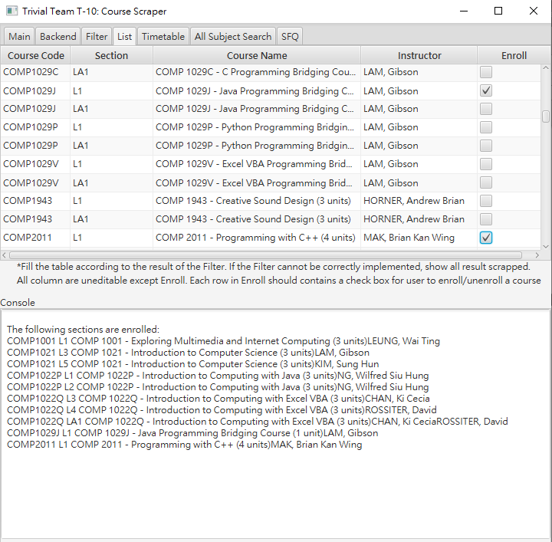

Unadjusted SFQ data for the enrolled courses are displayed after the Find SFQ with my enrolled course button is clicked

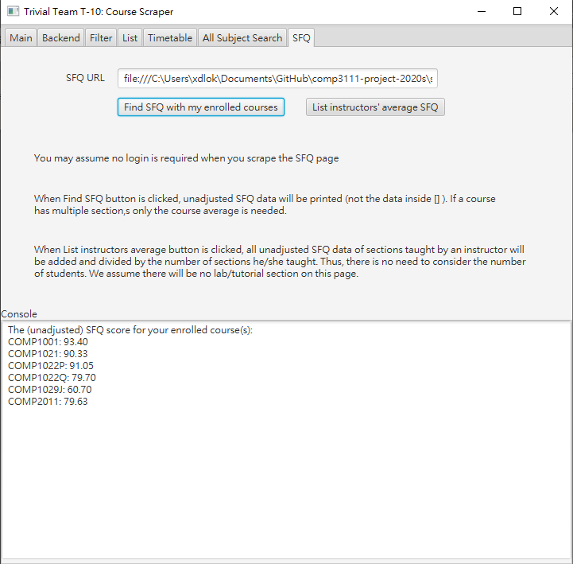

All instructors’ SFQ score are shown after List instructors’ average SFQ button is clicked

